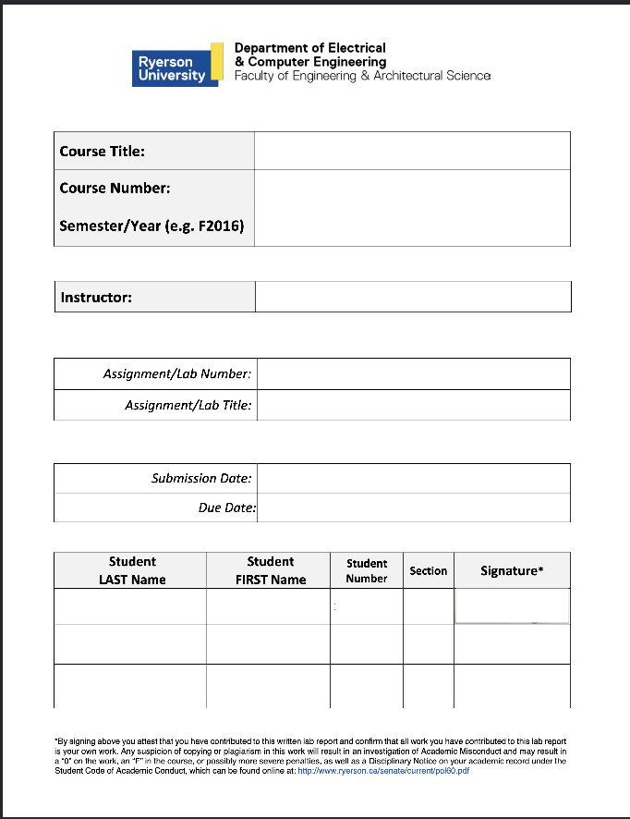
Electronic Circuits 1

P2024
Jassar, Surinder
1
Diodes
May 17, 2024
May 17, 2024
Mourad Shai
04
501170415
Sharma
Tanishq
501122854
04
TS
Table of Content
1. Introduction...........................................................................................R2
2. Objectives..............................................................................................R2
3. Circuit under Test..................................................................................R2
4. Experimental Results............................................................................R2
5. Conclusions and Remarks.....................................................................R3
6. Appendix: Signed Pre-Lab and TA Copy of Results...............................R6

Introduction:
In this lab, the I-V characteristics of the 1N4148 silicon diode were observed and the small-signal behavior of the diode in the forward-biased region was also examined.

Objectives:
Using the 1N4148 silicon diode along with varying resistances and currents in the forward-bias region, the I-V characteristics were examined. The small-signal behavior of the diode was also examined as mentioned in the introduction of the lab.

Circuit Under Test:
Attached below, Figure 1 shows the schematic of the circuit used in the lab. As it can be seen, the components of the circuit consist of a DC power source, a resistor and the 1N4148 diode all in a series circuit configuration. There were two variations that were used, both were almost the exact same except for configuration b) which had an extra resistor in parallel with the diode. VD1 and iD represent the voltage and currents across the diode in configuration a) while VD2 is the voltage across the diode in configuration b). The circuits were recreated in MultiSim which can be seen in Figure 2.

Figure 1: The two circuit variations used in the experiment
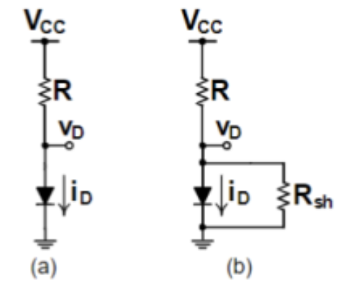

Experimental Results:
The circuits in Figure 2 were constructed on a breadboard and powered by a DC power supply at varying currents. For this lab, Vcc, Vd1 and Vd2 were experimentally obtained while the rest of the variables were calculated with the exception of Id1 and Rsh. The results from the lab can be observed below in Table 1.

Table 1: Table of measured and calculated results
iD1 [mA] | VCC [V] | vD1 [V] | Rsh [kΩ] | vD2 [V] | AvD [V] | AiD [mA] | rd [Ω]
10 | 10.73 | 0.7261 | 1.5 | 0.7198 | -0.0063 | -0.47987 | 13.12865
7 | 7.76 | 0.7066 | 2.2 | 0.7023 | -0.0043 | -0.31923 | 13.47003
5 | 5.80 | 0.6909 | 2.7 | 0.6880 | -0.0029 | -0.25481 | 11.38081
2 | 2.69 | 0.6468 | 6.8 | 0.6446 | -0.0022 | -0.09479 | 23.20819
1 | 1.62 | 0.6150 | 12 | 0.6118 | -0.0032 | -0.05098 | 62.76561

Conclusion and Remarks:
C1:
It is clear when looking at the graphs of Vi vs t and Vs vs t that they are quite similar, since they were both set to have the same frequency, and to be triangular waves in the function generator. It can also be seen that the peak voltage is 24 V for both graphs, which makes sense since the VPP is set to 12 V. Essentially both graphs are almost identical with one being the source voltage, and the other being the voltage drop across the 1k Ω resistor. The graph of Vd vs t, is also quite interesting because it only reaches a maximum of 700 mV or 0.7 V, which makes sense since this is the voltage that the diode itself will turn on. The graph of Id vs t, demonstrates a sort of rapid triangular pattern, similar to the first 2 graphs, however it can be seen that the current also flat-lines at certain time intervals. These time intervals are when the necessary voltage for the diode to turn on is not meant, therefore no current flows through at those specific time intervals. For the graph of Id vs Vd it appears to emit an exponential-like curve which makes sense, since at very low voltages the current is almost non-existent, while as the voltage reaches 0.7 V or 700 mV, it begins to rise in an exponential manner.

r5fC2:
A sample calculation, is shown below:
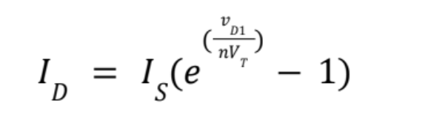
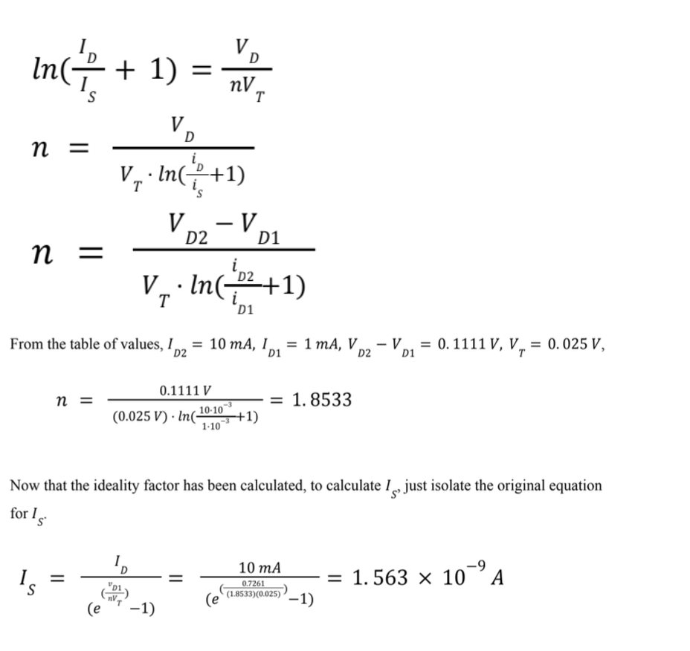

Here is the plot of the variables:
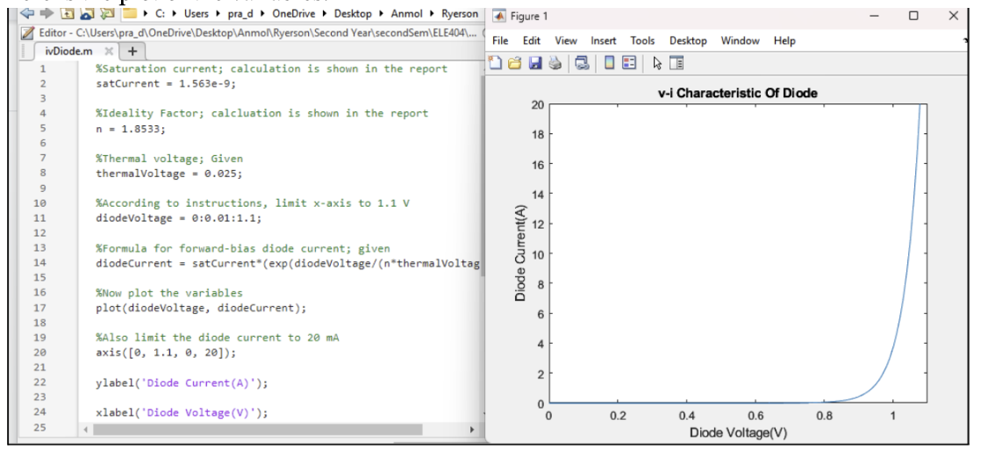

C3:
Table 2: Table of calculated r_{D} and the percentage error

Quiescent Current, I<sub>D</sub> [mA] | 10 | 7 | 5 | 2 | 1
Theoretical value of r<sub>D</sub> | 4.6332 | 6.6189 | 9.2665 | 23.1663 | 46.3325
Measured value of r<sub>D</sub> | 13.12865 | 13.47003 | 11.38081 | 23.20819 | 62.76561
Percent error, e% | 64.71% | 50.86% | 18.58% | 0.18% | 26.18%

C4:
To Determine the discrepancy between the theoretical and experimental values, the calculation below was done.

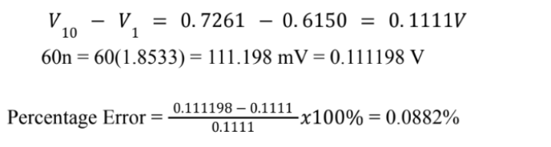
Therefore the results of this lab agree with the hypothesis that a 60n mV increase in the voltage would result in an increase in current by one decade. This is proved by the calculations above which show that the percentage error between the theoretical and experimental value was 0.0882% which is within the allowable range of uncertainty.

Appendix: Signed Pre-Lab and TA Copy of Results
Figure 2: The circuit constructed in MultiSim (same positions as Figure1)
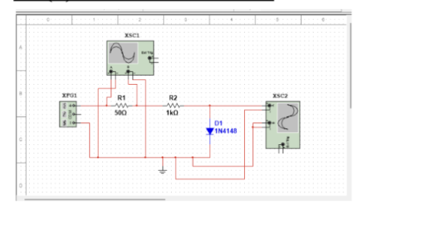

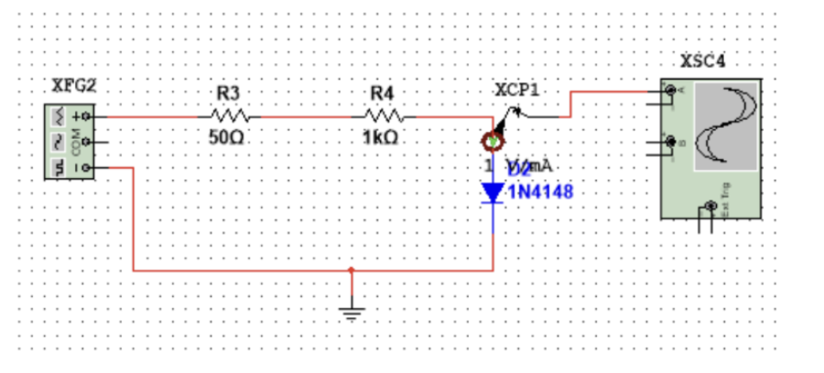

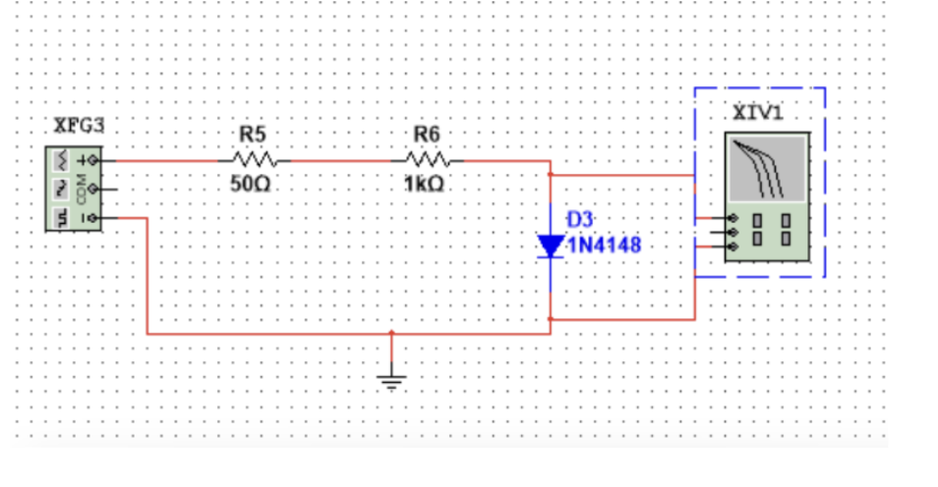

Graph 1: Multisim waveforms V_{S}, V_{I}, V_{D}, I_{D} vs t for circuits in Figure 2.

V_{S} vs t
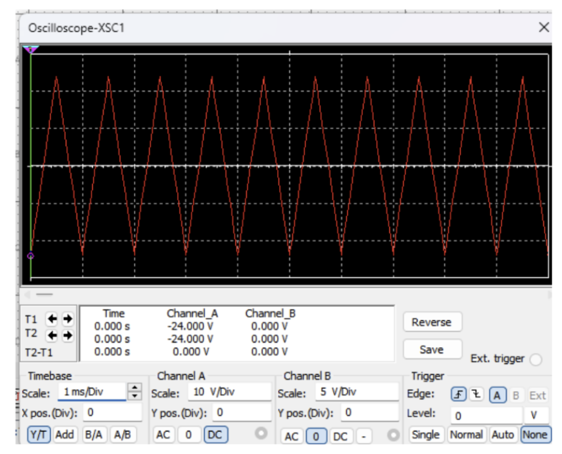

V_{I} vs t
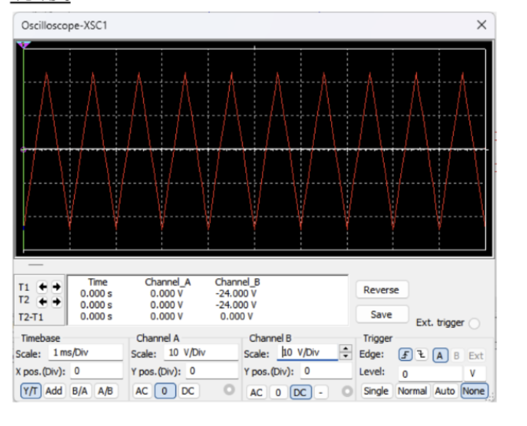

V_{D} vs t
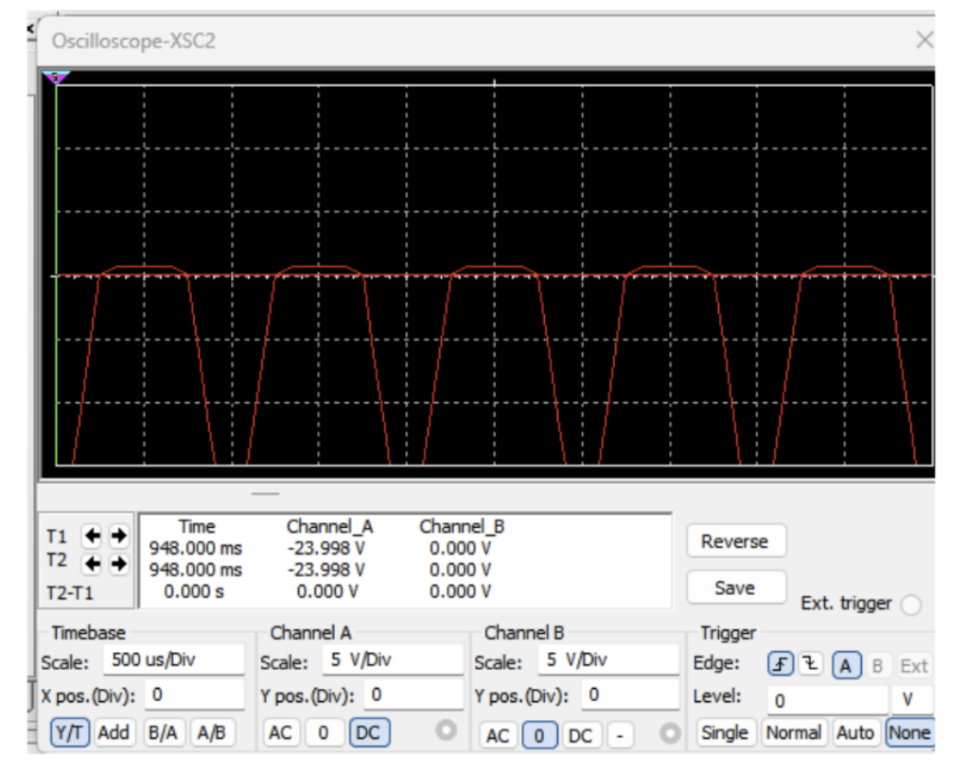
I_{D} vs t

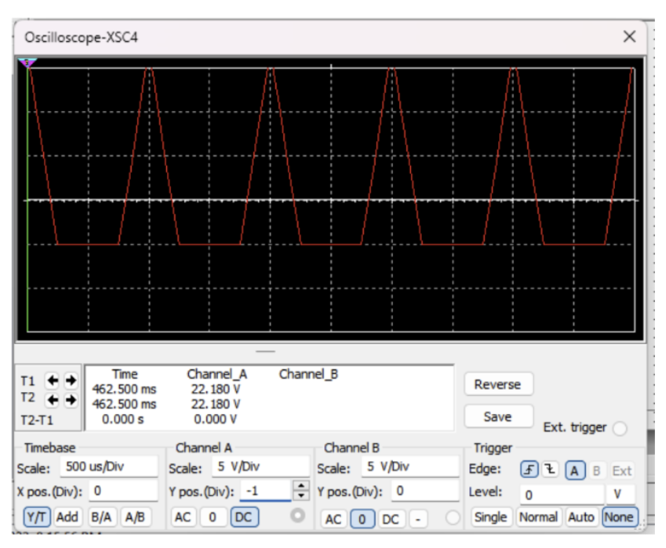

Graph 2: Multisim waveform simulation V_{D} vs I_{D} for circuit in Figure 2.
